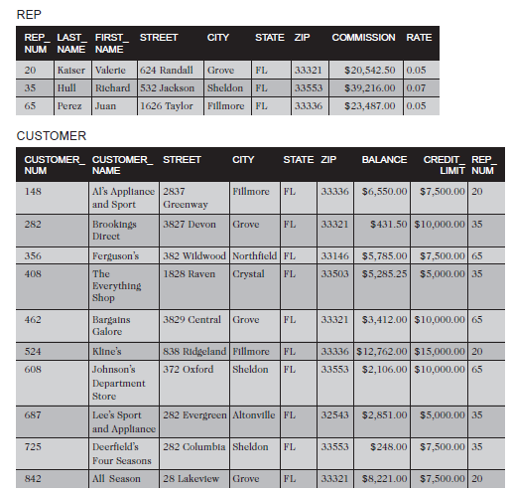

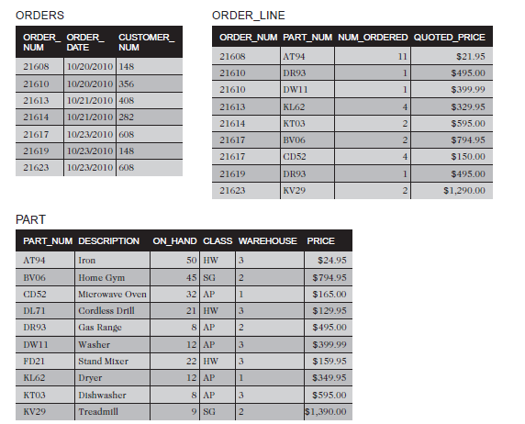

Entity-Relationship diagram:

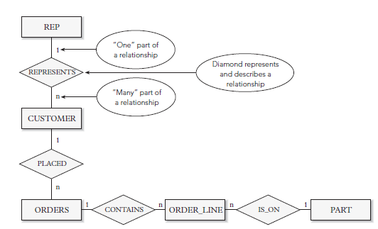

Functional Dependencies:

PART_NUM 🡪 DESCRIPTION, ON_HAND, CLASS, WAREHOUSE, PRICE

ORDER_NUM 🡪 ORDER_DATE, CUSTOMER_NUM

CUSTOMER_NUM 🡪 CUSTOMER_NAME

PART_NUM, ORDER_NUM 🡪 NUM_ORDERED, QUOTED_PRICE

Relations:

PART (PART_NUM, DESCRIPTION, ON_HAND, CLASS, WAREHOUSE, PRICE)

ORDERS (ORDER_NUM, ORDER_DATE, CUSTOMER_NUM)

CUSTOMER (CUSTOMER_NUM, CUSTOMER_NAME)

ORDER_LINE (PART_NUM, ORDER_NUM, NUM_ORDERED, QUOTED_PRICE)

INSERT INTO REP

VALUES ('20','Kaiser','Valerie','624 Randall','Grove','FL','33321',20542.50,0.05);

INSERT INTO REP VALUES

('35','Hull','Richard','532 Jackson','Sheldon','FL','33553',39216.00,0.07);

INSERT INTO REP

VALUES

('65','Perez','Juan','1626 Taylor','Fillmore','FL','33336',23487.00,0.05);

INSERT INTO CUSTOMER

VALUES

('148','Al''s Appliance and Sport','2837

Greenway','Fillmore','FL','33336',6550.00,7500.00,'20');

INSERT INTO CUSTOMER

VALUES

('282','Brookings Direct','3827

Devon','Grove','FL','33321',431.50,10000.00,'35');

INSERT INTO CUSTOMER

VALUES

('356','Ferguson''s','382

Wildwood','Northfield','FL','33146',5785.00,7500.00,'65');

INSERT INTO CUSTOMER

VALUES

('408','The Everything Shop','1828

Raven','Crystal','FL','33503',5285.25,5000.00,'35');

INSERT INTO CUSTOMER

VALUES

('462','Bargains Galore','3829

Central','Grove','FL','33321',3412.00,10000.00,'65');

INSERT INTO CUSTOMER

VALUES

('524','Kline''s','838

Ridgeland','Fillmore','FL','33336',12762.00,15000.00,'20');

INSERT INTO CUSTOMER

VALUES

('608','Johnson''s Department Store','372

Oxford','Sheldon','FL','33553',2106.00,10000.00,'65');

INSERT INTO CUSTOMER

VALUES

('687','Lee''s Sport and Appliance','282

Evergreen','Altonville','FL','32543',2851.00,5000.00,'35');

INSERT INTO CUSTOMER

VALUES

('725','Deerfield''s Four Seasons','282

Columbia','Sheldon','FL','33553',248.00,7500.00,'35');

INSERT INTO CUSTOMER

VALUES

('842','All Season','28 Lakeview','Grove','FL','33321',8221.00,7500.00,'20');

INSERT INTO ORDERS

VALUES

('21608','20-OCT-2010','148');

INSERT INTO ORDERS

VALUES

('21610','20-OCT-2010','356');

INSERT INTO ORDERS

VALUES

('21613','21-OCT-2010','408');

INSERT INTO ORDERS

VALUES

('21614','21-OCT-2010','282');

INSERT INTO ORDERS

VALUES

('21617','23-OCT-2010','608');

INSERT INTO ORDERS

VALUES

('21619','23-OCT-2010','148');

INSERT INTO ORDERS

VALUES

('21623','23-OCT-2010','608');

INSERT INTO PART

VALUES

('AT94','Iron',50,'HW','3',24.95);

INSERT INTO PART

VALUES

('BV06','Home Gym',45,'SG','2',794.95);

INSERT INTO PART

VALUES

('CD52','Microwave Oven',32,'AP','1',165.00);

INSERT INTO PART

VALUES

('DL71','Cordless Drill',21,'HW','3',129.95);

INSERT INTO PART

VALUES

('DR93','Gas Range',8,'AP','2',495.00);

INSERT INTO PART

VALUES

('DW11','Washer',12,'AP','3',399.99);

INSERT INTO PART

VALUES

('FD21','Stand Mixer',22,'HW','3',159.95);

INSERT INTO PART

VALUES

('KL62','Dryer',12,'AP','1',349.95);

INSERT INTO PART

VALUES

('KT03','Dishwasher',8,'AP','3',595.00);

INSERT INTO PART

VALUES

('KV29','Treadmill',9,'SG','2',1390.00);

INSERT INTO ORDER_LINE

VALUES

('21608','AT94',11,21.95);

INSERT INTO ORDER_LINE

VALUES

('21610','DR93',1,495.00);

INSERT INTO ORDER_LINE

VALUES

('21610','DW11',1,399.99);

INSERT INTO ORDER_LINE

VALUES

('21613','KL62',4,329.95);

INSERT INTO ORDER_LINE

VALUES

('21614','KT03',2,595.00);

INSERT INTO ORDER_LINE

VALUES

('21617','BV06',2,794.95);

INSERT INTO ORDER_LINE

VALUES

('21617','CD52',4,150.00);

INSERT INTO ORDER_LINE

VALUES

('21619','DR93',1,495.00);

INSERT INTO ORDER_LINE

VALUES

('21623','KV29',2,1290.00);